Supervised Learning Algorithms Part 2

Decision Tree:
When using the decision tree algorithm with the ClimateWins dataset I did need to prune it. With such a large data set the decision tree was unable to be read. When I purned it just to focus on three of the weather stations it was still too large to read, however, it was a better representation than when I had. I personally would have looked at each weather station individually. For the sake of time and not over consuming my RAM I left it at three weather stations.
When using the confusion matrix to view multiple matrices you can tell that there is improvement from the training matrix to the testing matrix. In the decision tree matrix I didn’t specify the labels “unpleasant” and “pleasant”. Keep in mind that 0 = pleasant and 1 = unpleasant. There are more counts of pleasant days than unpleasant days.
Artificial Neural Networks:
When exploring the scaled data the image generated exhibited very small changes. I wouldn’t say that scaling the ClimateWins data would make much of a difference but there is some scaling that happens.
I continued to run the multiple-confusion matrices, and I did noticed that the labels were not provided. I don’t understand why but again 0 = pleasant and 1 = unpleasant. When reading the accuracy, the third gave the best accuracy over 60%. It’s nowhere near perfect but it’s much higher than the original 43%. Below are three training and testing matrices.
Remaining Questions:
If I had to select one of the algorithms that I believe best predict the Climate Wins data, I would go with he ANN. I would pick this because I feel like I’d have more control to help the algorithm reach the predictions as closely as possible because I have the power to change the iteration, hidden layer and tolerance.
I did like the decision tree to help you see more of a visual of how the prediction would find it’s answer. If I dove more into the decision tree the probability that it could also give great answers would be high. No weather station is completely accurate but there are some high accuracies in quite a few of the weather stations.
I can’t say that overfitting is finding it’s way in these algorithms. I don’t find certain features that might contribute to the accuracy of the algorithms either.
Training 1
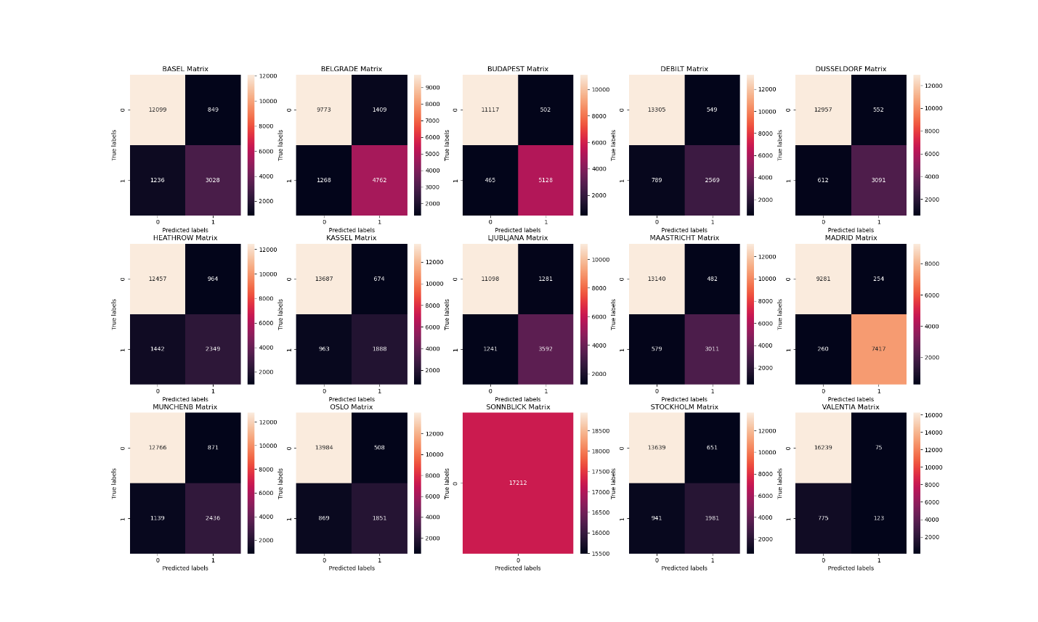
Test 1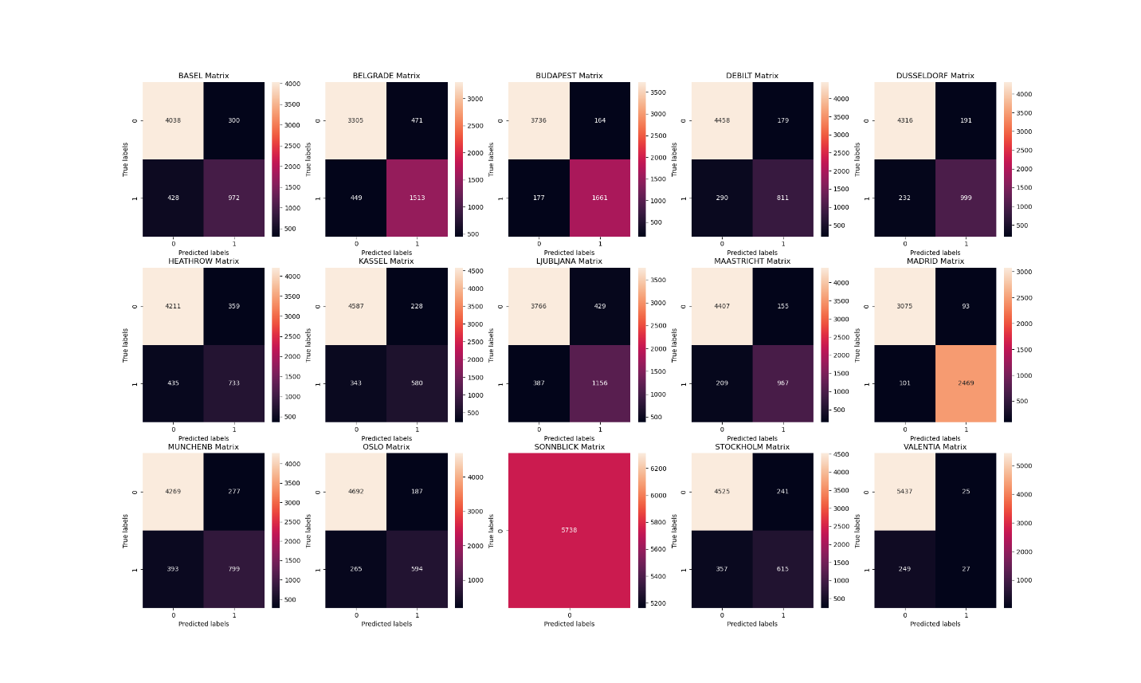
Training 2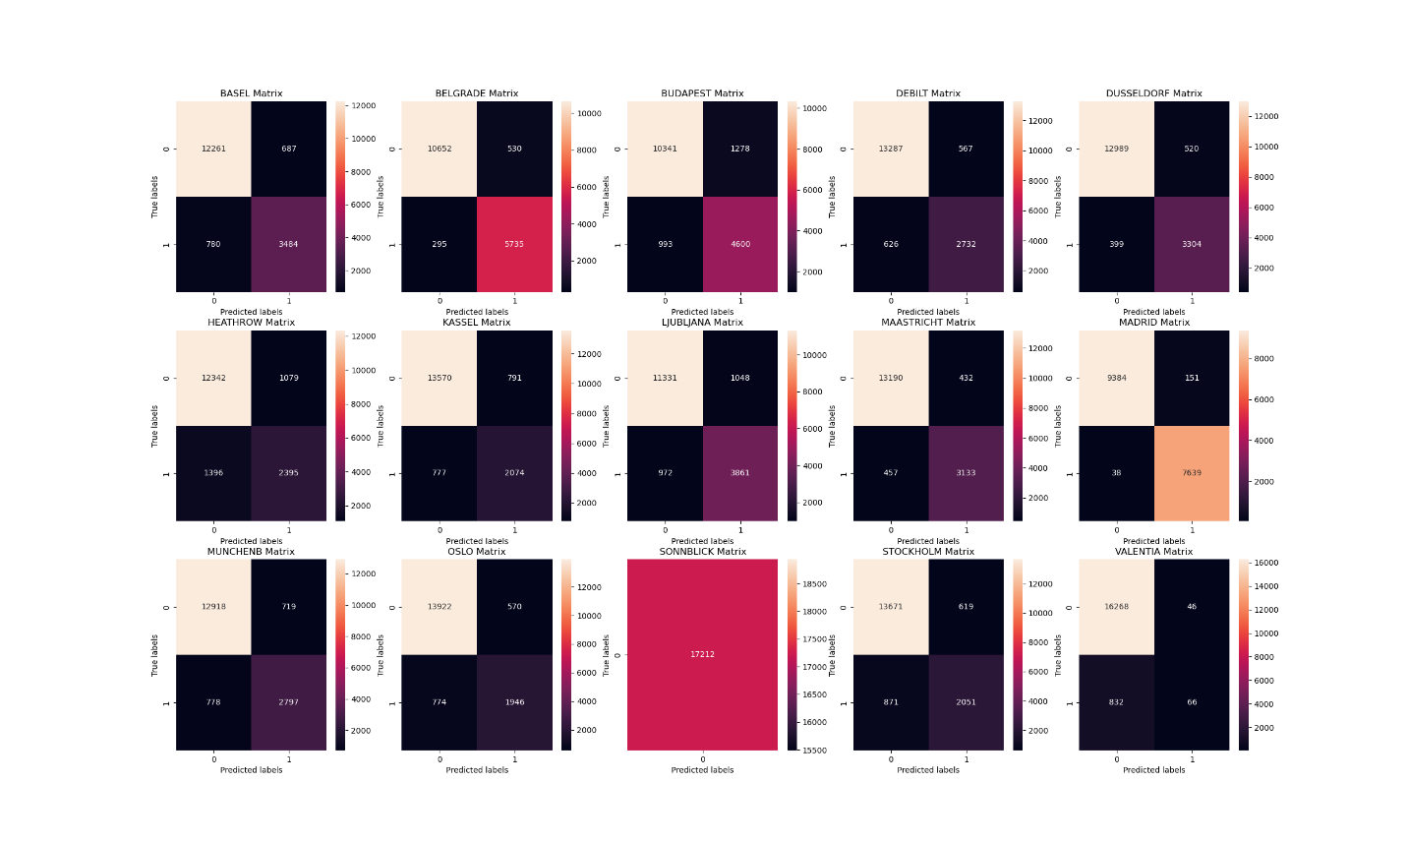
Test 2 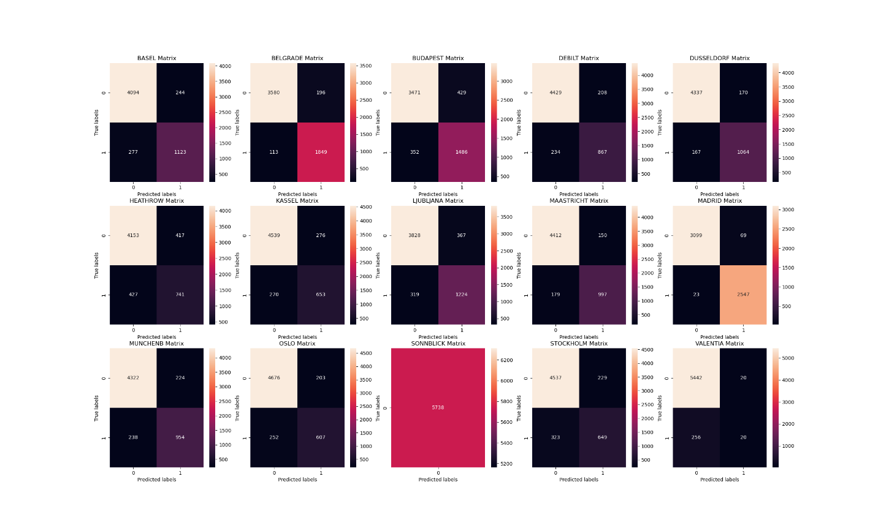
Training 3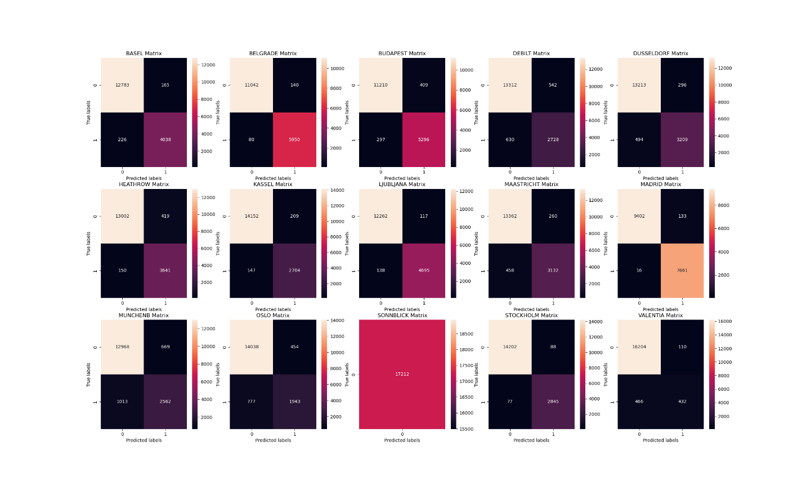
Test 3 